6th WHO – IUMSP INTERNATIONAL SEMINAR ON THE PUBLIC HEALTH ASPECTS OF NONCOMMUNICABLE DISEASES, LAUSANNE, 7 – 12 MAY 2012

WELCOME DINNER

MONDAY, 7 MAY, 2012
RESTAURANT «CAFE DE L’EVECHE», RUE LOUIS-CURTAT 4, LAUSANNE

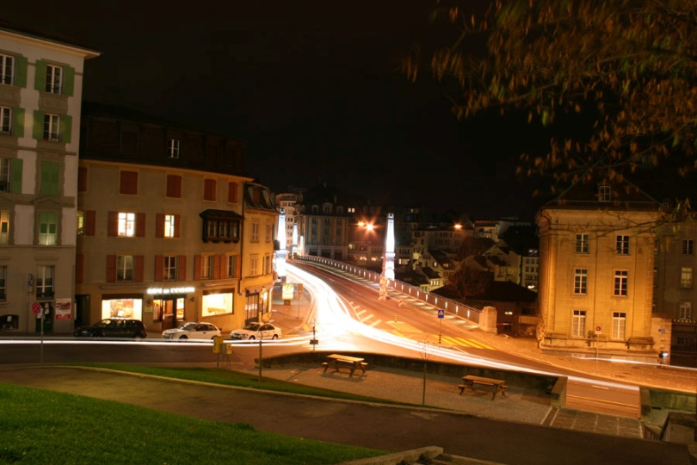

PROGRAM OF THE EVENING

5:50 pm Meeting in the lobby of the Hotel Aulac
6:00 pm (sharp) We leave Hotel Aulac to the metro station “Ouchy”
6:10 pm We start our short walk in the city from the metro station « Riponne Maurice-Béjart »
6:15 – 08:00 pm Visit of the town of Lausanne by the “Rue de “l’Ale”, “Place Bel-Air”, “Place de l’Europe”, “Place Pépinet” and visit of the old town through“Place de la Palud” with Town Hall (effective walking time is ~30 min)
8:00 – 10:00pm Dinner at the restaurant « Café de L’Evêché », the meal is offered but drinks will be at your own charge
10:00 pm Short walk to metro station “Bessières” and metro to Hotel Aulac, Ouchy
Dress code: casual, please take comfortable shoes for the short walk in the city

